**Cedefop launches vocational education and training in Europe database**

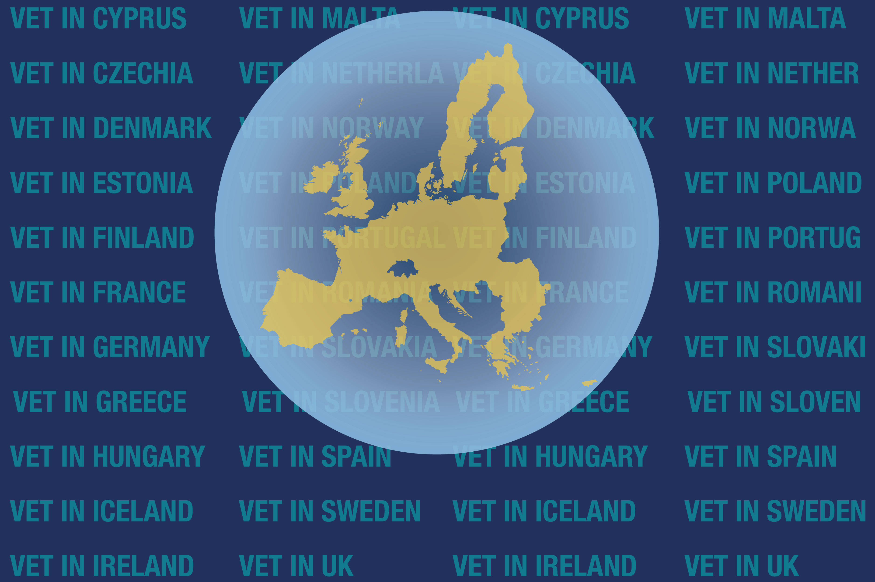

**The**[**new Cedefop database**](https://www.cedefop.europa.eu/en/tools/vet-in-europe/)**is the main source of information about vocational education and training (VET) systems in the European Union, Iceland and Norway.**

It helps policy-makers, social partners, researchers and other stakeholders better understand similarities and differences of national VET systems through easy-to-navigate up-to-date descriptions structured by theme. The database also contains detailed information about each VET programme type, including qualification levels, share of work-based learning, providers and target groups.

The [**database**](https://www.cedefop.europa.eu/en/tools/vet-in-europe/) displays information in a way that can be readily accessed and interpreted. It:

* offers more than 2 500 pages of data accessible through a single screen;
* allows comparing information by country and theme;
* includes national VET system diagrammes;
* generates downloadable national reports.

Cedefop has designed, piloted and populated the database in cooperation with national partners to provide access to VET system information for all, and to meet specific user needs. These needs were identified during a pan-European evaluation that preceded the database development.

Data collection is being supported by **[ReferNet](http://www.cedefop.europa.eu/en/events-and-projects/networks/refernet)** – a network of institutions across Europe representing all EU Member States, Iceland and Norway.

Use our quick feedback form on the main screen to let us know how the database inspired you and what can be further improved.

Stay tuned – updates on VET systems in EU countries will be added in 2021.